How to color in photoshop using the magic wand tool

- Bring your scanned zine into Photoshop, and name the layer “Zine” by double clicking on its name in the layers panel.

- Create a new layer under the Layers tab or by clicking on the New Layer icon at the bottom of the layers panel , name it “Color.” Reselect the Zine layer. 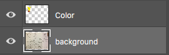

- Select the magic wand tool

- The magic wand tool can only select closed areas with a defined boundary. Click into a closed area you’d like to color. Holding the shift key down allows you to make multiple selections. Holding Alt allows you to deselect.

- You may have to use the brush tool to close off a panel of your zine or darken faint lines on shapes that aren’t well-defined.

- If the area you are trying to select is giving you trouble you may have to increase the tolerance to a higher number so more pixels are selected or decrease the number so less pixels are selected. Tolerance is located at the top of the page near the select tab.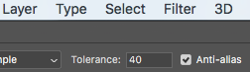
- Once you have an area selected that you’d like to color, select your “Color” layer.

- Next, click on the brush tool

- You can select your color by double clicking the forward most square at the bottom of your toolbar or by going to window>color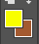

- Be sure that when you are coloring, you are coloring on your “Color” layer not your “Zine” and when you are using the magic wand tool you are on your “Zine” layer.

Pasting an image behind complex selections

- Find an image from the internet or that you have taken
- You can either save the image to your desktop or simply click the image and drag it into photoshop. Either way you are clicking the file/image and dragging it into photoshop. This will automatically create a new layer.
- Pressing Command T will allow you to freely transform your image to get it into the size you want. Click enter when it is sized properly.
**Make sure you hold down the Shift key while transforming if you don’t want to stretch your image.
- Once it is adequately sized, place the image into the position you want it. Now click the eye icon to make this layer temporarily invisible
- Next select the layer you want to post something behind. In this case it is our “Zine” layer.
- Select the magic wand tool
- Using the magic wand tool, click into the open area where you’d like to post your image.
- You may need to block out the page of your zine using your brush tool as shown 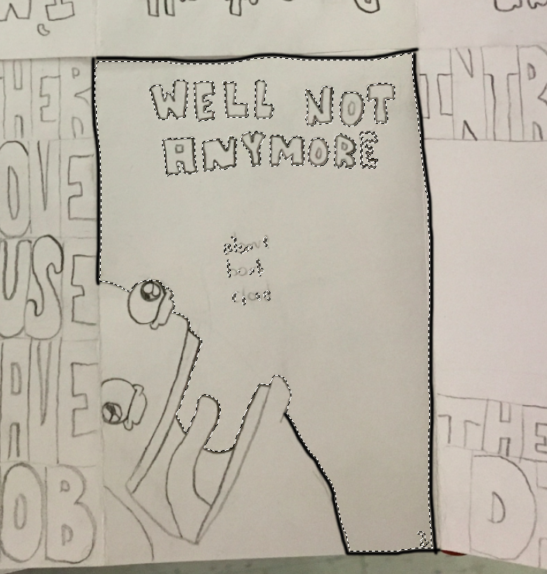
- If the area you are trying to select is giving you trouble you may have to increase the tolerance to a higher number so more pixels are selected or decrease the number so less pixels are selected. Tolerance is located at the top of the page near the select tab.

- Once the area you want to post your image is adequately selected go to the select tab and click select>inverse. This will invert your magic wand selection.
- Now select the layer that was made when you dragged the image into photoshop. Reclick on the eye icon to make it visible again.
- Now click the delete button. This should delete everything that was not in the area that we selected. This allows our image to be pasted behind whatever we want. This process can be repeated for any area necessary.

